**Date :** 1/10/2022

**Roll No. and Name :** 22BCE538 Shah Kaivan

**Course Code and Name :** 2CS302 Object Oriented Programming

**Practical No.: 1 (b).i**

**AIM:** Write a program in C to display and count a total number of duplicate elements in an array.

**Methodology followed:**

**Input:**

|  |
| --- |
| #include<stdio.h>  #include<conio.h>  int main()  {  int c=0,i,j;  int a[6]={2,1,2,3,3,1};  for(i=0;i<6;i++)  {  for(j=i+1;j<=6;j++)  {  if(a[j]==a[i])  {  c++;  printf("DuplicateElements: %d\n",a[i]);  }  }  }  printf("Total no. of Duplicate elements found in array: %d",c);  return 0;  }  **Output:** |
|  |

**Conclusion :**

I learnt that how can I count duplicate element in array using for loop and printing of these elements.

**Practical No.: 1 (b).ii**

**AIM:** Write a program in C to count the frequency of each element of an array.

**Methodology followed:**

**Input:**

#include<stdio.h>

#include<conio.h>

int main()

{

int i,j,k=0,n;

int a[n],a1[n],a2[n];

printf("Enter No. of elements to be stored in array: ");

scanf("%d",&n);

printf("Enter %d elemets: \n",n);

for(i=0;i<n;i++)

{

printf("Element-%d: ",i);

scanf("%d",&a[i]);

}

for(i=0;i<n;i++)

{

if(a[i]==0) continue;

int c=1;

for(j=i+1;j<n;j++)

{

if(a[j]==a[i])

{

c++;

a[j]=0;

}

}

a1[k]=a[i];

a2[k]=c;

k++;

}

printf("The frequency of all elements of an array: \n");

for(i=0;i<k;i++)

{

printf("%d occurs %d times\n",a1[i],a2[i]);

}

printf("\n");

return 0;

}

**Output:**

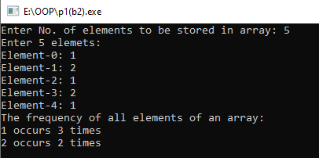

**Conclusion :**

I am able to find frequency of all elements in array using nested loops and how to store these details.

**Practical No.: 1 (c)**

**AIM:** Write a Java program to display greeting message like: First Java Program….” on console.

**Methodology followed:**

**Input:**

class First

{

public static void main(String args[])

{

System.out.println("My First Java Program");

}

}

**Output:**

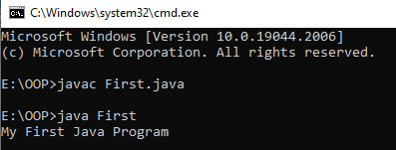

**Conclusion :**

I wrote my first code in java and get brief introduction and learnt about printing strings in java. I learnt terminal command to compile and run the code in java.

**Practical No.: 1 (d)**

**AIM:** Write a Java program to display all primitive type variables. Also display your name in the last line.

**Methodology followed:**

**Input:**

class Primitive

{

public static void main(String args[])

{

byte b=18;

int i=99;

boolean bool=true;

float f=99.99f;

double d=99.999999d;

short s=9;

char c='K';

String str="Shah Kaivan";

System.out.println("Value of Byte Variable: "+b);

System.out.println("Value of Integer Variable: "+i);

System.out.println("Value of Boolean Variable: "+bool);

System.out.println("Value of Float Variable: "+f);

System.out.println("Value of Double Variable: "+d);

System.out.println("Value of Short Variable: "+s);

System.out.println("Value of Character Variable: "+c);

System.out.println(str);

}

}

**Output:**

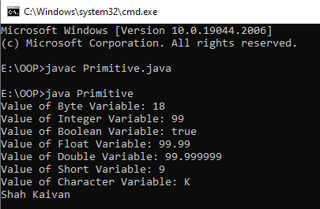

**Conclusion :**

I learnt about primitive data types in java and how to use that. I also got knowledge about every data-type’s size and its importance.